CSCI251 A1 Summary
Interpretation of requirements
- config.txt must contain the specific file names (citylocation.txt, cloudcover.txt, config.txt,
- pressure.txt)

Program Summary
A1_main.cpp
- Provides menu for user interaction

Program flow
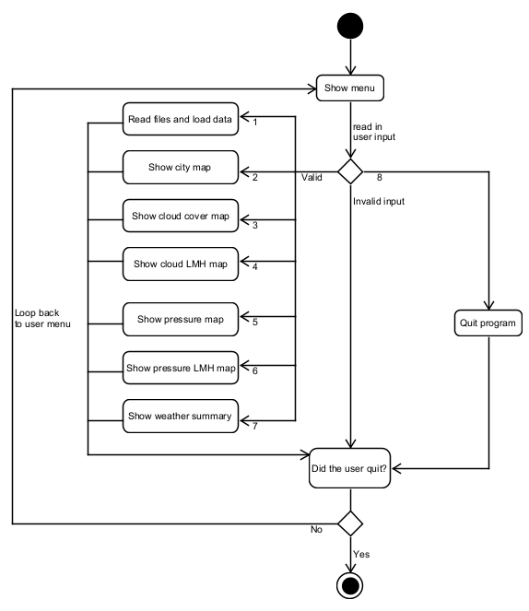

wips.h
- Declare all necessary header files, data structures and public functions callable by main()

Data structures
- Struct of each cell (GridCell)
- Members:
- x and y coordinate
- City ID
- City Name
- Cloud Cover value
- Pressure value

- Map for City ID and City Name (cities)
- Arranged in Descending Order of city ID
- Enables unique cities (by City ID) to be recorded
- Used for weather summary report

- Pointer-to-pointer for 2D array (weatherMap)
- Used for map display

wips.cpp
loadFile() function
- Arguments:
- Minimum and Maximum X and Y values (int)
- cities (map)

- Function Calls:
- readConfigFile()
  - Read X and Y values from File

- initMap()
  - Based on the Maximum and Minimum X and Y values, dynamically generate a 2D array (GridCell) with the same dimensions

- readCityFile()
  - Read in the x and y coordinates and place the City ID and City name in the 2D array
    - Use getMapCell() to find the location of the cells using the x and y coordinates
  - Record unique city ID and city Name into cities (map)
    - Map will store the city ID in descending order

- readCloudFile()
  - Record cloud cover values for each cell into the map

- readPressureFile()
  - Record pressure values for each cell into the map

displayMap() function
- Arguments:
- weatherMap (2D array pointer)
- maximum and minimum X and Y values (int)
- pointer-to-function (void)

- Pass a different function in depending on the implementation:
- city() Display the cities
- cloudIndex() Display the cloud Index value
- cloudLMH() Display the cloud LMH value
- pressureIndex() Display the pressure Index value
- pressureLMH() Display the pressure LMH value

displayWeatherSummary()
- Iterate through the map use the city ID to get the necessary values
- Arguments
- cities (map)
- weatherMap (2D array pointer)
- minimum and maximum X and Y values (int)

- Functions
- getCityAvg()
  - Loop through the 2D array and find the lowest [x,y] and highest [x,y] with the specific city ID to find the bounds of the city
  - Check if the bounds are within the map (don’t exceed the minimum and maximum X and Y values)
    - Increment 1 if value is within the map

  - Loop through the x and y values of the identified bounds
    - Use getMapCell() to retrieve the cloud cover / pressure value of the cell
    - Increment 1 to get number of cells

  - Calculate average

- convertLMH()
  - Convert the Value to LMH symbols

- getRainProb()
  - Check if pressure is L, M or H
  - Check if cloud cover is L, M or H
  - Return the respective values

- drawWeatherGraphic()
  - Set the default cloud columns as 4 and number of rain symbols as 0
  - If (50 <= rainProb <= 90)
    - Set the number of rain symbols as
(rainProb / 10) – 4
    - Keep cloud columns as 4 (since 4 is the max and does not change for rainProb >= 50)
  - If (10 <= rainProb < 40)
    - Set the cloud column as
(rainProb / 10)
    - Keep rainProb as 0 (since no rain for rainProb <= 40)
  - Print out the respective clouds and rains

deleteMap()
- Deallocate memory for the pointer and set to null
- Arguments:
- weatherMap (2D array pointer)
- minimum and maximum Y values (int)

Reflection
I learnt how to write my program to do file encapsulation, how to use string stream library to transform integers to strings, how to use other data structures part of the standard library such as maps, that can store key-value pairs, and how to do File IO by searching strings to retrieve data in C++.
I faced difficulty in File IO due to unfamiliarity with the language specific functions. I also faced many compilation errors due unfamiliarity with file encapsulation and writing the .h file. Lastly, I also faced issues with the displaying of cities as I could not resize my array when needed, which led me to learn more about sets and maps, which help with uniqueness of the cities
I think I could have done better input validation and maybe split the implementation module into separate modules which would make the code more readable and help with debugging.

